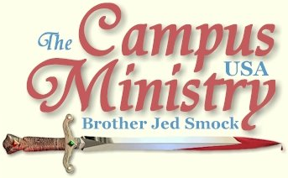
brojed.org
brojed@aol.com
573-999-0347

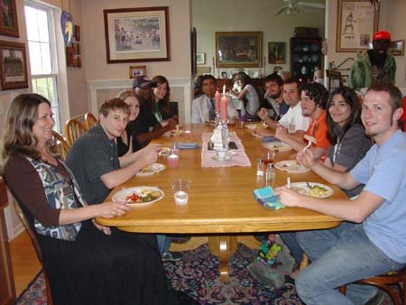
We had another large turnout of Mizzou students for our biannual open house on April 16.
See details and more photos below.

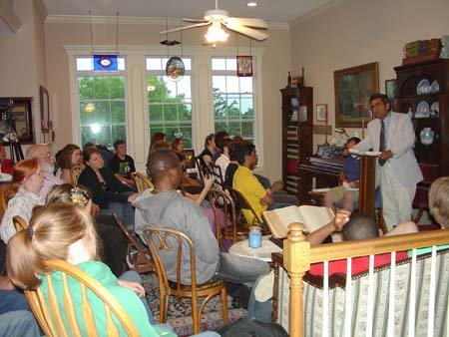
We concluded the open house with a debate between Bro. Jed and Atheist Dave. See below for details and how to watch the debate on you-tube.

WHITE LAB JACKETS, BLACK ROBES OR BLACK BIBLE?

University of Missouri, April 12, 2010,

The Jehovah Witnesses had a table set up on the Circle. I do not ever recall seeing them at Mizzou. However, they folded up their table when Dr. Mike A., a physician at the University hospital, started preaching. He usually comes out to preach on Monday. He read from Genesis 1. About a dozen students gathered as he read and commented. I think it makes an impression on the students when a scientist speaks out against evolution. However, the students will not admit that it shakes them. Still they tend to get quite agitated. Dr. A. is softer spoken in his speaking style than I am, but he doesn’t pull his punches. He is strong on making it clear that a Christian will live a holy life. Dr. A. gave an early history of the world up until the Tower of Babel incident and the scattering of different groups throughout Europe, Africa, India and the Far East. He spoke of the call of Abraham and the rise of the Jews. He taught through the 1 PM break until 10 minutes after the hour. When someone asked about original sin, he answered that he did not believe the doctrine. He called upon me to explain. I answered that men are born with a human nature with the capacity to do right or wrong, good or evil. Alas, we have all chosen to live selfishly. Hence we need a Savior.

At noon Bro Cope arrived from Pennsylvania. Since the students had heard me all the past week, I called upon Bro. He addressed his favorite subject which is speaking against evolution. Bro’s background is in Computer Science. He is very well read in the Creation vs. Evolution debate. He teaches that the earth is only 6000 to 10,000 years old. He had several students very riled up. Most of them have brought into the evolution myth hook, line and sinker.

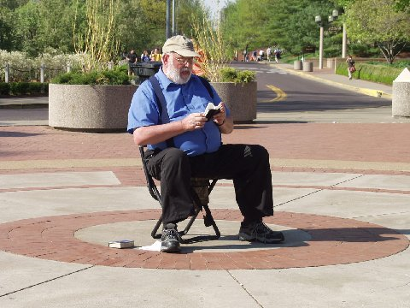
Bro Cope looking up a verse to answer a question.

I spoke from 2-3. I briefly gave my usual argument against evolution explaining that we intuitively know that we must be created since we have dignity as men. However, the students have lost their sense of dignity after being told they are animals all their life, and so many behave like animals. They are out of touch with their intuition since they have been brainwashed by the public schools and the myths of the media. They rarely question anything the PhD’s in the white lab jackets tell them. They have displaced the authority of the monks and priests of black robes in Medieval Times. As for me, I will go with my black authorized Bible KJV.

From 3-4 Bro continued to address the evolution issue. From 4-5 I changed the direction and emphasized moral issues. Someone wanted to compare the Bible to the Harry Potter series. I explained that the author of Harry Potter was not claiming to write anything more than fiction. The authors of the OT frequently use phrases such as, “Thus says the Lord.” Jesus considered the OT as authoritative when he used the expression, “It is written.”

I preached until 5 PM. The crowds for most of the afternoon hovered around 50.

WE OUTLAST THEM ALL

University of Missouri, April 13, 2010,

Chi Alpha, the Assemblies of God campus ministry, had a literature table set up on the outer circle. They held signs which read, “Pie a Christian.” Sometimes they yelled, “Pie a Christian; you know you want to.” They were also giving away free lemonade. The Phi Mu sorority had set up a table with a radio in the center of the circle. They were raising money for a children’s hospital. Bro started preaching away from the center circle. After about 20 minutes he wanted me to take over stating, “I cannot get any traction.” The Chi Alphas were having difficulty getting anyone to throw a pie at them.

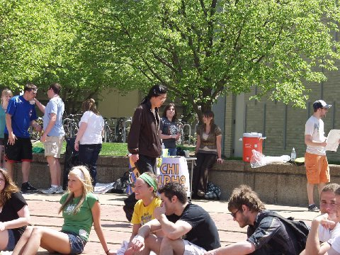
CHI ALPHA Table in the background.

I started by promoting our open house in a humorous way explaining the Moslem’s were welcome but since we believe in profiling they would be subject to frisking before entering our home. Gays, lesbians, bisexuals and transsexuals could come but two men were not allowed to go to one of the bathrooms with another man. I managed to gather a group of a dozen or so around me.

I also announced that I was not with the Chi Alpha group. I was not asking to be pied. I confronted a man who had most of his arm tattooed with words from Homer’s Iliad. I explained that St. Paul bore in his body the marks of the Lord Jesus. I tried to convince this fellow that those are the types of marks that he should have on his body. And when men take the kind of stand Paul took, their body will be well marked. A pie will leave no mark on the body. The tattoo man had been raised by his grandparents, whose last name was Christian. But they had never taken him to church. I announced Jesus had his body pierced for standing for the Truth. You students pierce your own bodies as some sort of fashion statement or in a desperate attempt for recognition or for perversion’s sake. After I said this, a boy with a pierced tongue stuck it out. I gained some traction for a good hour and turned it back to Bro, who mostly talked against evolution. Bro did have a group of boys who were following his arguments. However, his teaching was apparently too deep for most of the students.

I finally took over again and announced that we needed to bring the girls back into the conversation by talking about sex. Sex usually captures the attention of a lot more students than the creation vs. evolution debate. But when Cindy and Martha arrived with some of their home school friends, I changed the subject. I expounded upon the beatitudes to an attentive audience of about twenty for a good thirty minutes. “Blessed are they which are persecuted for righteousness sake.” When Christians start taking the kind of stand they ought to be taking for righteousness, we won’t have to ask to be pied to draw attention to our ministry or message. We will be reviled. And we will become the center of attention.

At 3:45 I called on Sister Cindy. Since I had been talking on the admonition to be fruitful and multiply, students wanted to know if Cindy agreed with me. So she introduced the students to our fourth child, Martha, who is happy that we did not stop with three. So many Americans are stopping at one or two these days. Students made the common objections of overpopulation which we explain as a myth. The problem in the world is not overpopulation; it is underproduction.

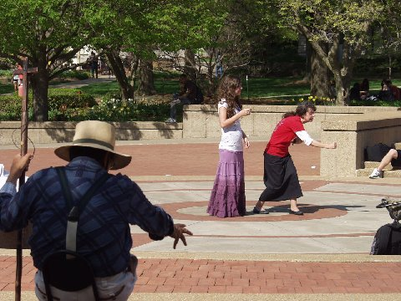
Sister Cindy preaching and Martha waiting to speak.
Note Bro. Jed preaching along with his wife:)
"The two shall be one."

While Cindy spoke a group of Moslem’s cornered me because they had heard that I threatened to frisk Moslems who came to our home. I explained that I was kidding. One Saudi Moslem admitted that in his country homosexuals were subject to being thrown off a building. He admitted that when he came to American he was shocked at the drinking and all the illicit sexual behavior. But he eventually adapted to this culture and now gets drunk, parties and has sex himself. He expressed concern that if he did not do these things and if he went to the mosque daily to pray that people would be suspicious that he is a terrorist.

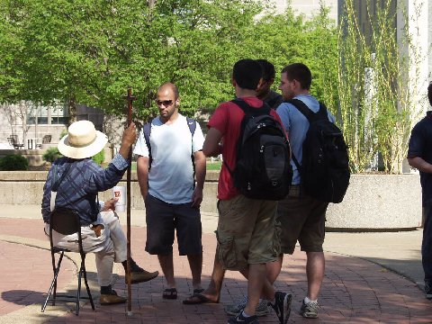
Islamic students question Bro. Jed

We outlasted the other groups as we usually do. The Chi Alphas finally did get a few to throw pies at them. Evidently, the children had some money raised for them by the sorority sisters and their men helpers. We gave many something to think about as we threw back the Word of God against all the barbs and questions tossed at us.

THE JUSTICE OF ETERNAL DAMNATION

University of Missouri, April 14, 2010,

Bro preached for about 30 minutes to one person, Dave M., the atheist, whom I will be debating Friday night at our open house. Dave would sometimes stop Bro to give him some feedback. Dave claims he is an atheist because there is no evidence for God. Bro told him of a number of incidents in his life where God had done miracles. But Dave rejected the supernatural as evidence. Of course, Dave, is looking for scientific evidence. Bro explained that science is that which is observable, repeatable and falsifiable. The evidence Bro gave was personal testimony of experiencing the supernatural over and over. Dave is a naturalist who completely rejects the supernatural. He presupposes naturalism and his presupposition prevents him from accepting the supernatural. Bro accused Dave of having a double standard in that he demands evidence but refuses to accept any evidence with which he is confronted. After a while several others joined Bro and Dave in the circle.

At 1:10 Bro called upon me. I had planned a teaching on the Justice of Eternal Damnation for an apologetics seminar I am giving for home schoolers tonight. I had my notes with me including many texts on the subject of Hell. I read several texts from the OT, Jesus’ key texts on Hell and finished with readings from The Revelation. I mustered all of my dramatic abilities to make the Hell verses real to the students so much so that I was becoming fearful myself as I read. Most of the thirty or so in the circle listened in silence with little interruption.

I referred to Dante, who following Virgil, arrived at the gates of Hell where were inscribed these dreadful words: "To rear me was the task of Power divine, Supremest Wisdom, and primeval Love. Before me things created were none, save things Eternal, and eternal I endure."

Hell is a testimony to the power, wisdom, and love of God, who created Hell not for men but for the devil and the fallen angels. Later man followed Lucifer in rebellion and consequently God has had to at intervals enlarge Hell to accommodate the multitudes of unbelievers that fall into "the bottomless pit" daily.

I raised the question, “How is it just for God to damn sinners forever for sins committed in a relatively short life time?” I stressed that Hell is a bottomless pit, the sinner falling, falling, falling, falling, but never reaching the bottom. The wicked one never stops sinning in Hell. O he won’t be getting drunk or stoned in Hell, but his selfishness, bitterness and his hatred of God and his tormented companions in the fiery furnace will wax worse and worse. Neither his sin nor torment ever “bottoms out” in the place where “the worm (consciousness) dies not.”

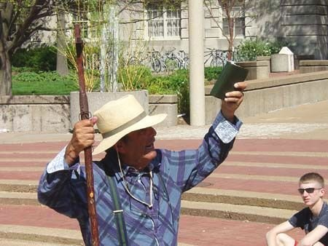
The Eternal Flames:
Be Warned!

The effects of sin are perpetual; in a like manner the manifestations of the disapproval of God must be endless. How many multitudes has an atheist like Bertrand Russell long after his death continued to influence through his writings? The effects of his sin are infinite. Therefore, he, like all unbelievers, deserves endless punishment.

God has a responsibility to counteract the evils of sin and repair the damage evil has done in the world. Any procedure such as annihilation that could diminish or question the certainty of God's displeasure toward sin would only encourage men in their iniquity.

As miserable as sinners will be in Hell, they would be even more miserable in Heaven. They have hated the church militant so would they despise the church triumphant. They have preferred the companionship of fools and scoffers over that of the righteous and wise on earth, so they will in eternity. Hell is the best and most loving thing God can do for the impenitent.

The Bible describes Hell as "the fire that shall never be quenched." I asked, ”Is the fire literal or figurative?” Sinners better hope that these fires are literal, because, if figurative, eternal damnation is something worse than a "furnace of fire", since a symbol is less, not greater, than the thing symbolized. However, either way, whether literal or figurative our Lord is describing something terrible, something we should avoid at the cost of plucking out our offending eye, or cutting off our offending foot or hand. Hell is a horrible place no warning is too strong.

I spoke for over an hour on this dreadful doctrine. Students have never heard Hell more vividly described or more reasonably justified than they did this afternoon as a mighty anointing of God was upon me. Of course, virtually none of them have ever heard any teaching in support of Hell that amounts to a hill of beans. Some of them may have heard teaching against the doctrine of Hell.

If there is no Hell, there must be no loving God. If in the end the righteous and wicked receive the same reward then God would not be just. Should God allow Heaven to become Hell by allowing the wicked to enter? The peace of heaven must not be disturbed. What makes heaven heaven, but the absence of evil?

A few passed by and mocked and laughed. But I warned that God will get the last laugh (Proverbs 1). I waxed more and more eloquent as I preached. I was physically weak after I finished the message and very thirsty.

But I was revived after I took my second turn from 3:30-4:30 and I reviewed in a calmer matter some of the points which I had made concerning Hell. Students had some good questions. I was even asked about the necessity of atoning sacrifices. I explained that the animal sacrifices were not sufficient for taking away sin. A greater sacrifice, a human sacrifice, indeed, the sacrifice of God himself was necessary to change the hearts of men. The atonement of our Savior was God’s desperate attempt to save men from sin and Hell. Once again a strong anointing was upon me but not so much the terror of the Lord as in the previous hour, but God’s love and compassion was moving in and through me as I pleaded with students to turn away from sin unto the living God.

My last thirty minutes I explained the difference between a King and president. I demonstrated how Obama acts more as a tyrannical king rather than a president of a republic. It was a very good day for me. I thought today that I need to speak more often from notes instead of almost always speaking extemporaneously.

THE HOLOCAUST OF CHRIST

University of Missouri, April 15, 2010,

When Bro and I arrived, Jews had already occupied the inner circle and raised a banner which read, “NEVER FORGET, 6 million, Holocaust Remembrance Week.” All afternoon different students read names of individuals who died in the holocaust. Usually three or four were reading names at once. One could not hear the names unless they were close to the readers. Generally, the readers were being ignored. The reading is something Jewish students do annually at Mizzou.

I put on my sandwich board sign which pictures various sins typical to students. I stood in front of a group of friends who hang out daily in the outer part of the circle. It wasn’t long before this group started kissing one another on the lips often in a French way. It made no difference to them if they kissed the opposite sex or the same sex. It was quite a disgusting display. Others hanging out on the circle did not seemed fazed by this public flaunting of perversion.

The Young Communist League took center circle for a while to do a skit depicting an Afghanistan village bombed my American planes, claiming that this skit was typical of America destroying innocent women and children. I directed my comments towards the commies and reminded them that we are in Afghanistan because the Taliban harbored terrorists and are terrorists themselves. One old communist bag protested my interrupting their skit and she called the police. A policeman arrived and asked me not to challenge the protestors. When Bro started videoing our conversation, the policeman threatened Bro with arrest. I pointed out that there is free speech in Speakers’ Circle; people confront and heckle me daily. The policeman backed off somewhat. I think that he knew he did not have a leg to stand on. The skit was already over by the time the police arrived. I returned to the outer circle and began reproving the group of perverts. Meanwhile an angry man shook his fist in my face for preaching while the names were being read. I suggest that perhaps the names of Americans who gave their lives liberating the Jews from the Nazis in World War II ought to be read and never forgotten.
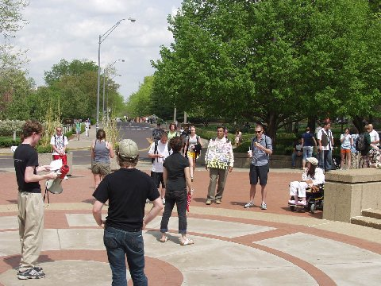
Anti-War Skit, Bro. Jed Heckles

Tuesdays and Thursdays at Mizzou are usually more difficult days since there are fewer class breaks and fewer students taking classes. Then we were at a disadvantage since center circle was occupied. At one point I warned the students that if they do not change their ways and get saved that God has a holocaust prepared for them which is the Lake of Fire. God will not discriminate; Jews and Gentiles will be in this Holocaust together. Jesus said, "And fear not them which kill the body, but are not able to kill the soul: but rather fear him which is able to destroy both soul and body in hell."
I warned them to never forget that Jesus was delivered by the Jews to the Pontius Pilate to be crucified. The definition of Holocaust includes “a sacrificial offering that is consumed entirely by flames.” Jesus said, “Zeal for my Father’s house has consumed me.”
We Christians should be reminding the world of the holocaust of Christ and the holocaust of Hell.
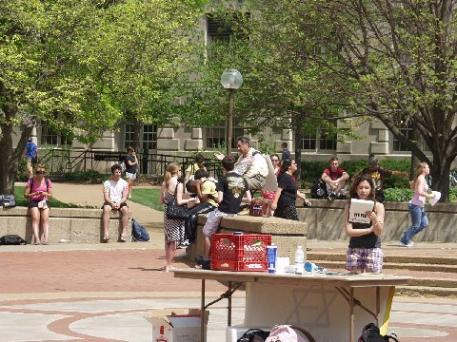
Holocaust reader is in the front. Bro Jed is in the background seated with the sandwich board and a small crowd.

At 2 PM I suggest to Bro that we call it a day. The Jews seemed to be settled in for the afternoon. Bro thought it would be good to stay around so I agreed. Finally, by 3:30 Bro gathered several students around him by speaking on the rebellious history of the Jews. When a boy and girl who had been dialoging with Bro left, I shouted at them to warn them that they were making a big mistake by leaving. They came over and started a conversation with Rocket and me. Soon others joined us at the wall of the outer circle. The students were attentive and had thoughtful questions. I noticed there was a girl sitting on the wall the whole time about 30 feet from us. Within an hour she moved and sat on the wall beside us. She never said a word, but I handed her an invitation to our open house. The last 90 minutes redeemed our day.

A journalism student had scheduled a recorded interview with me in Townshend Hall. In the morning another student had driven almost four hours from Springfield to interview me for a religious studies class he was taking at Missouri State. The recorded interview will go in the library archives of the Oral History of the Ozarks. I am regularly interviewed for various class projects.

OUR OPEN HOUSE
AND DEBATE
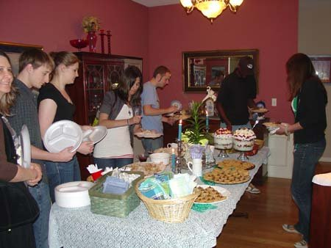
Plenty of Food

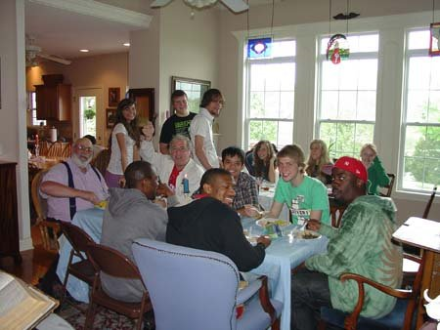
Lots of Great Dinner Discussion

University of Missouri, April 16, 2010,

The temperature dropped today and there was a light rain. We waited to preach until the 1 PM break hoping the weather would clear. I sat on the wall of the outer circle under a tree holding my warning sign with lists of potentially damnable sins sign.

Several students came up to talk to me about the sign, especially asking, “What is wrong with socialism and feminism?” Bro took center circle despite a very light rain. He also succeeded in gathering several students. Eventually, I took center circle still holding my sign; by this time the rain stopped.

We had from 35-75 for most of the afternoon. A man completely covered in a green suit harassed us for about an hour. His antic just drew a larger crowd for us to reach.

The last hour Bro addressed creationism from a scientific point of view. He is very well versed in this area and he impressed a number of the students. Late in the afternoon they were calmly asking him many questions. I heard Tanya say, “He should be a professor at this University.” She is often a sarcastic girl, but I did not take this statement as sarcasm. But either way, her statement was correct. Bro has self-educated himself very well in geology which enables him to argue convincingly for a young earth and vanquish all of his foes who have been taught the billions and billions of years theory.

We stopped at 4 PM and I drove three students to our home for our open house which began at 5:30. We had 35 students show up and 10 other guests including family friends and home schoolers. We had four dinner tables set up and a buffet table.

At my table, after some individual conversations with students sitting close to me, a student asked, “Why I did I hold up the sign which said feminism and socialism are sins?” Today was the first day that I used the list of sins sign this spring. His question resulted in a good 40 minutes of heated table talk concerning these issues. When it was time to break up the tables for our debate, I said to the student who had asked me about the sign, “We may disagree, but now you know why I hold the sign. It gets peoples’ attention. It stirs up dialogue, debate and discussion.” He got my point.

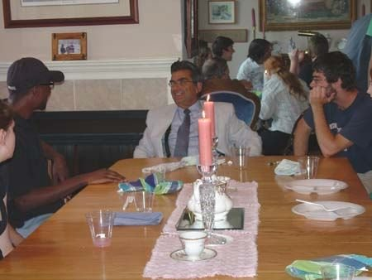
Explaining our message and approach.
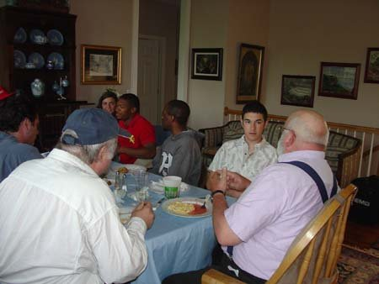
Bro discusses Evolution VS. Creation with Josh, a micro-biology major. Martha talks with three students in the background.


All these girls had come to one of our open houses before. Jason, in the green shirt, designed our new web site and he was the debate moderator.
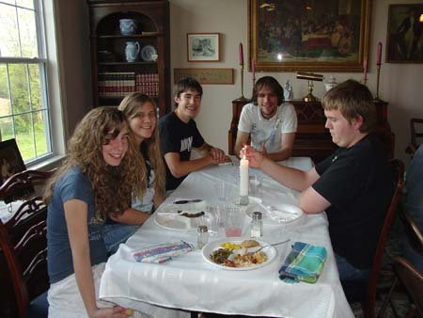
Home school kids, Priscilla, Shelby, Jonathan, Dustin and Sean. They were a big help with everything.

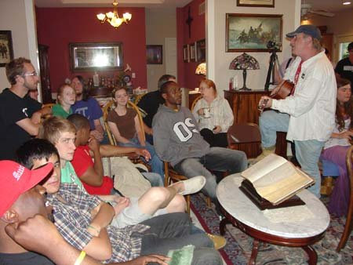
Local musician Rocket shares a song before the debate begins.

The debate with Dave Muscato took place in our living room with chairs set up overflowing into the kitchen and dining room theater style. Dave and I each spoke for 10, 8, and 5 minutes. I defended the position, “Why I am a Christians; Dave defended, “Why I am an atheist.”

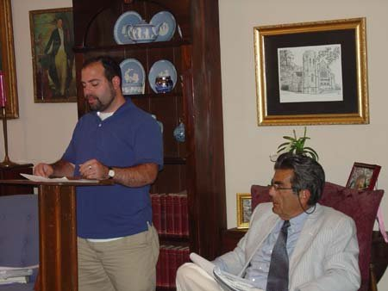
Atheist Dave Muscato defends his position.
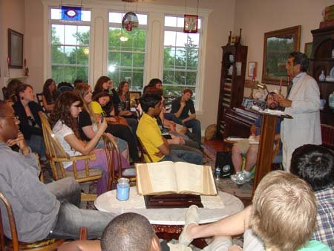
Only about half of the attendees professed faith in Christ.

I understood Dave’s basic point to be that since he cannot know whether there is a God or not, he assumes no one else can know either. Dave wanted physical evidence. I countered that I cannot give physical evidence of a metaphysical being.

I defended the authority of the Bible and the testimony of its authors. Most of what we know is not gained through first hand experiences, but the testimony of others. Why should not this also be true of God?

I spoke extensively of my own experience. I explained that Christianity enables us to devise the most consistent system of thought with the fewest difficulties. Christianity authenticates itself by giving meaning to everything that is.

We intuitively know that life has meaning. Children shortly after they start talking ask, “Why?” They assume there is meaning to life, we all do. We are constantly asking, “What does that mean?”

However, if we remove God from the equation and the hope of life beyond the grave, then to quote Shakespeare’s Macbeth, “Life is simply a tale told by an idiot, full of sound and fury, signifying nothing.” There has to be a God to give meaning and purpose to life. Without God, man has no dignity and life has no meaning.

We had another hour of each of us responding to questions from the audience. The debate ended at 9 PM but a number of the students stayed until 10:30. After that Rocket reported that he had a conversation with several atheists in front of our house for another half hour.

These fall and spring open houses are highlights of our ministry. Each one seems to get better. Cindy, Bro, Rocket, the girls and I all agreed that this was the best one ever. We usually say this after each open house.

It is my dream to have a house within walking distance to campus so that we can have students over for dinner and table talk on a weekly basis. Cindy, Martha and Priscilla along with two home school friends, Sean and Shelby worked real hard to put all of this together. Cindy cooked 20 pounds of pork roast and two turkeys along with a potato casseroles, corn, green beans, tri-fruit with whipped cream, cookies, etc. The students all ate heartily. And more importantly they were fed plenty of spiritual food that they may chew on for the rest of their lives.

You may veiw the debate by going to my you-tube account. It is downloaded in twelve 10 minute segments. Encourage your friends and family to watch it:
http://www.youtube.com/user/BrotherjedCMUSA#p/a
A Testimony
Brother Jed, thank you for your obedience to Christ, and declaring his message not only to the lost but also to us fellow, followers of Christ. I thank you for allowing johnny v, and myself the opportunity to accompany at the Chico state campus, since your visit, and the experience we had with you, our Christianity has been revolutionalized, it has totally changed, we now understand the ability Christ has given us to be able to fulfill his will and the call to be holy, and walk in his righteousness, thank you once again!! We are all rising up here in our church and taking a new stand, God is doing a new thing!!
John, April 18, 2010
You may donate to CMUSA by mailing to our home office at 2402 Longview Dr., Columbia, Missouri or through Pay Pal by going to our web site, brojed.org. Gifts are tax deductible.

